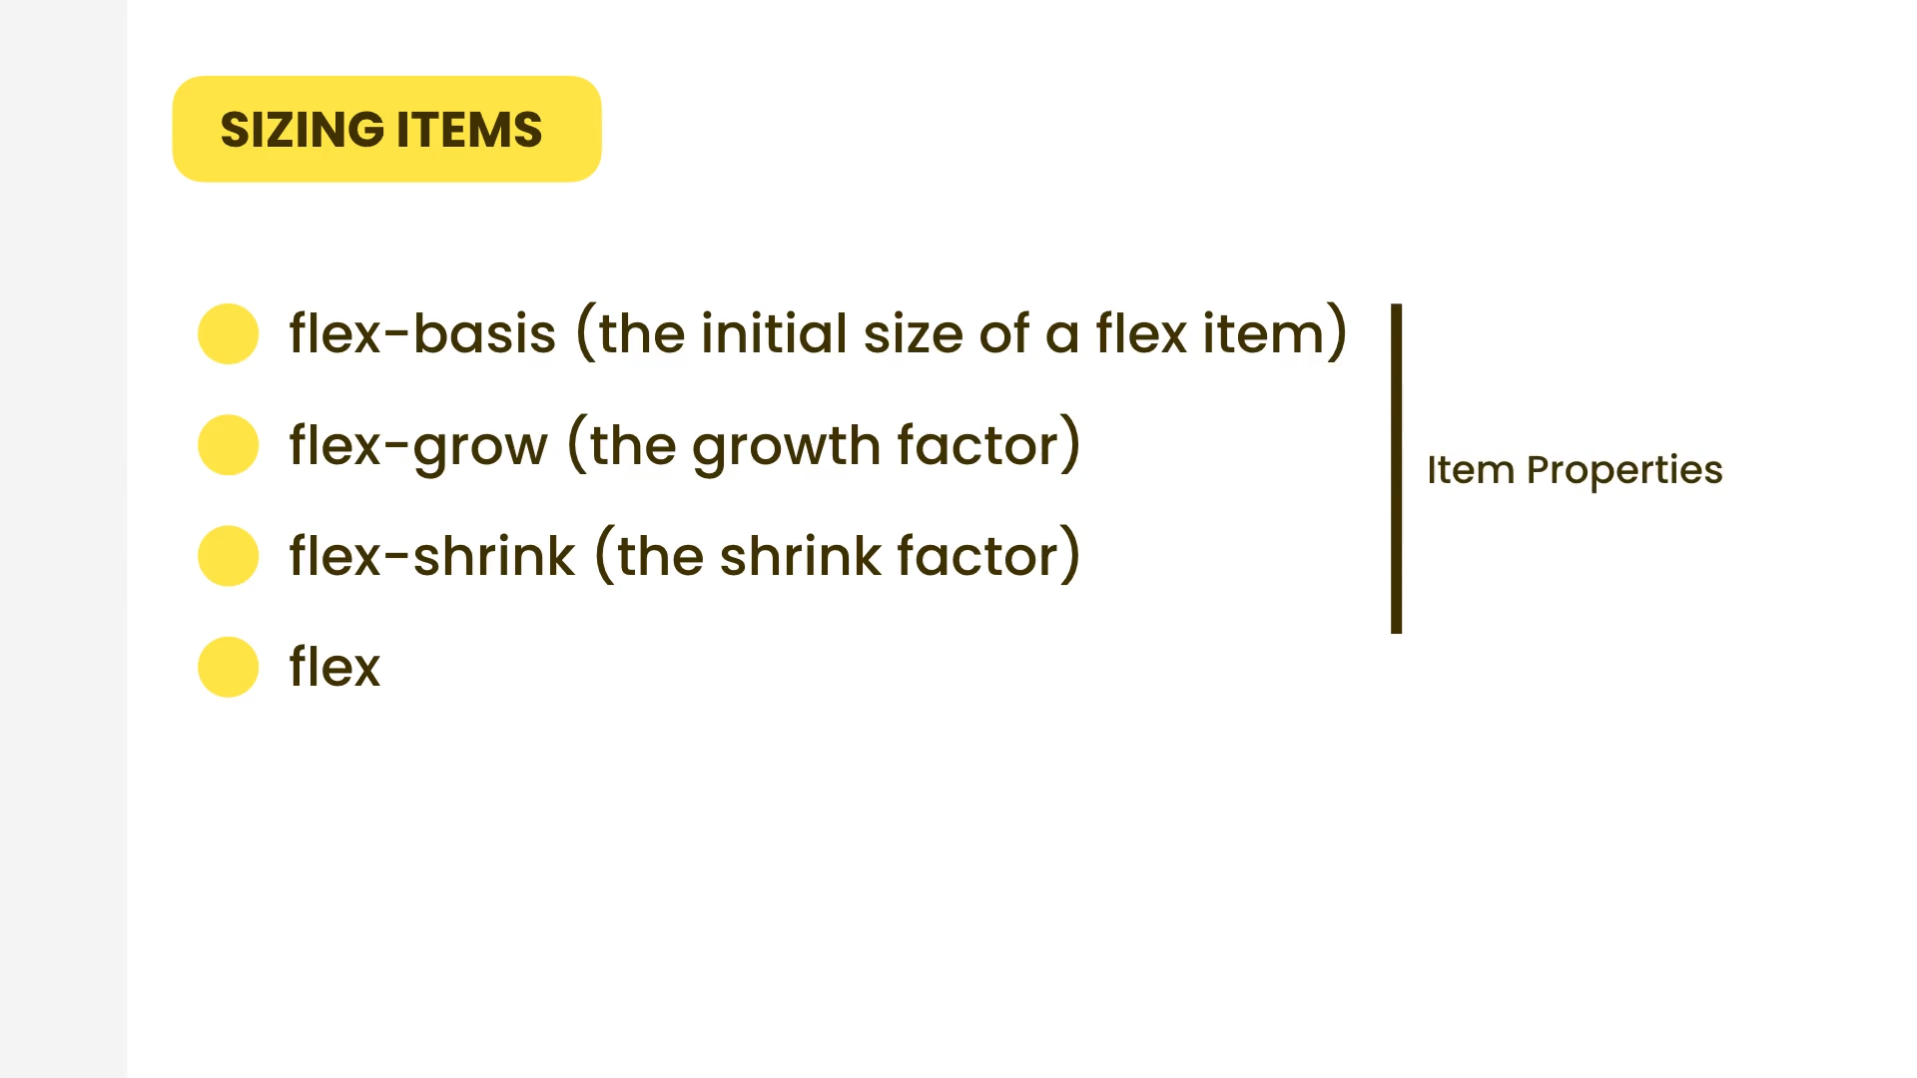

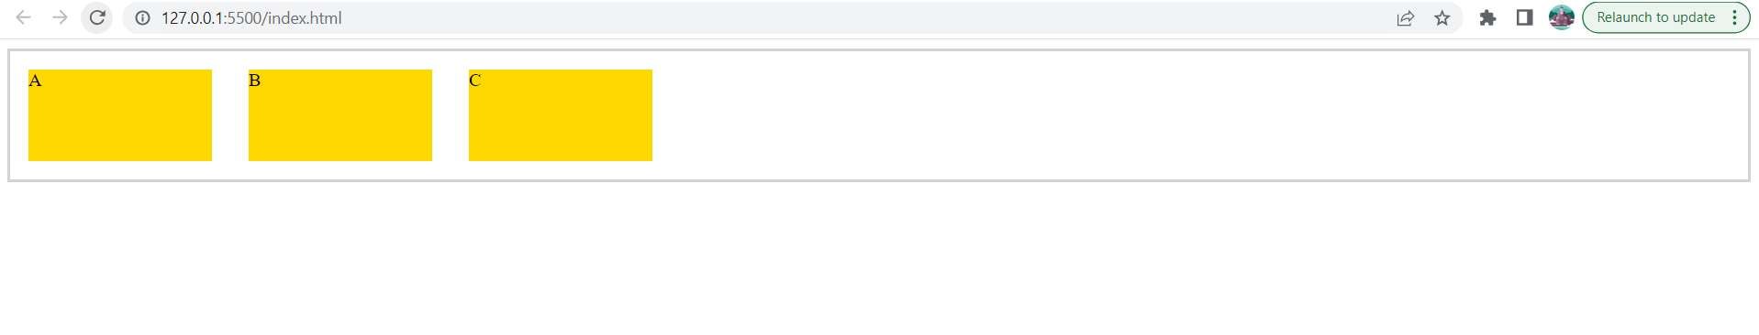

<div class="container">

<div class="box">A</div>

<div class="box">B</div>

<div class="box">C</div>

</div>

.container

{

    display: flex;

    flex-direction: row;

    border: 3px solid lightgrey;

}

.box

{

    flex-basis: 10rem;

    width: 5rem;

    height: 5rem;

    background: gold;

    margin: 1rem;

}

Flex basis translates to width if flex direction is row.

Flex basis translates to height if flex direction is column.

|  |  |
| --- | --- |
| Class | Properties |
| basis-0 | flex-basis: 0px; |
| basis-1 | flex-basis: 0.25rem; /* 4px */ |
| basis-2 | flex-basis: 0.5rem; /* 8px */ |
| basis-3 | flex-basis: 0.75rem; /* 12px */ |
| basis-4 | flex-basis: 1rem; /* 16px */ |
| basis-5 | flex-basis: 1.25rem; /* 20px */ |
| basis-6 | flex-basis: 1.5rem; /* 24px */ |
| basis-7 | flex-basis: 1.75rem; /* 28px */ |
| basis-8 | flex-basis: 2rem; /* 32px */ |
| basis-9 | flex-basis: 2.25rem; /* 36px */ |
| basis-10 | flex-basis: 2.5rem; /* 40px */ |
| basis-11 | flex-basis: 2.75rem; /* 44px */ |
| basis-12 | flex-basis: 3rem; /* 48px */ |
| basis-14 | flex-basis: 3.5rem; /* 56px */ |
| basis-16 | flex-basis: 4rem; /* 64px */ |
| basis-20 | flex-basis: 5rem; /* 80px */ |
| basis-24 | flex-basis: 6rem; /* 96px */ |
| basis-28 | flex-basis: 7rem; /* 112px */ |
| basis-32 | flex-basis: 8rem; /* 128px */ |
| basis-36 | flex-basis: 9rem; /* 144px */ |
| basis-40 | flex-basis: 10rem; /* 160px */ |
| basis-44 | flex-basis: 11rem; /* 176px */ |

|  |  |
| --- | --- |
| basis-48 | flex-basis: 12rem; /* 192px */ |
| basis-52 | flex-basis: 13rem; /* 208px */ |
| basis-56 | flex-basis: 14rem; /* 224px */ |
| basis-60 | flex-basis: 15rem; /* 240px */ |
| basis-64 | flex-basis: 16rem; /* 256px */ |
| basis-72 | flex-basis: 18rem; /* 288px */ |
| basis-80 | flex-basis: 20rem; /* 320px */ |
| basis-96 | flex-basis: 24rem; /* 384px */ |
| basis-auto | flex-basis: auto; |
| basis-px | flex-basis: 1px; |
| basis-0.5 | flex-basis: 0.125rem; /* 2px */ |
| basis-1.5 | flex-basis: 0.375rem; /* 6px */ |
| basis-2.5 | flex-basis: 0.625rem; /* 10px */ |
| basis-3.5 | flex-basis: 0.875rem; /* 14px */ |
| basis-1/2 | flex-basis: 50%; |
| basis-1/3 | flex-basis: 33.333333%; |
| basis-2/3 | flex-basis: 66.666667%; |
| basis-1/4 | flex-basis: 25%; |
| basis-2/4 | flex-basis: 50%; |
| basis-3/4 | flex-basis: 75%; |
| basis-1/5 | flex-basis: 20%; |
| basis-2/5 | flex-basis: 40%; |
| basis-3/5 | flex-basis: 60%; |
| basis-4/5 | flex-basis: 80%; |
| basis-1/6 | flex-basis: 16.666667%; |
| basis-2/6 | flex-basis: 33.333333%; |
| basis-3/6 | flex-basis: 50%; |
| basis-4/6 | flex-basis: 66.666667%; |
| basis-5/6 | flex-basis: 83.333333%; |
| basis-1/12 | flex-basis: 8.333333%; |
| basis-2/12 | flex-basis: 16.666667%; |
| basis-3/12 | flex-basis: 25%; |
| basis-4/12 | flex-basis: 33.333333%; |
| basis-5/12 | flex-basis: 41.666667%; |
| basis-6/12 | flex-basis: 50%; |
| basis-7/12 | flex-basis: 58.333333%; |
| basis-8/12 | flex-basis: 66.666667%; |
| basis-9/12 | flex-basis: 75%; |
| basis-10/12 | flex-basis: 83.333333%; |
| basis-11/12 | flex-basis: 91.666667%; |
| basis-full | flex-basis: 100%; |